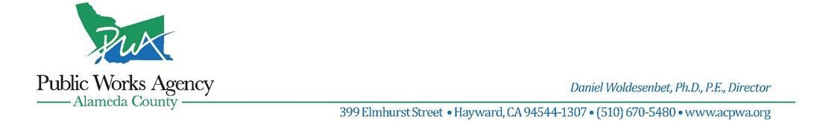

**PRESS RELEASE**

**FOR FURTHER INFORMATION FOR IMMEDIATE RELEASE**

Email: [info@acpwa.org](mailto:info@acpwa.org) **October 4, 2024**

**MINES ROAD OPEN AT MILE MARKER 6.50**

UNINCORPORATED ALAMEDA COUNTY – Please be advised that **Mines Road at Mile Marker 6.50 is now OPEN.**

The roadway was originally scheduled to be closed to traffic until October 19, 2024. However, by expediting construction and working around the clock, the contractor was able to complete the project in less than a week, significantly ahead of the planned three-week closure.

***For more information and project updates, please visit the Alameda County Public Works Agency website at www.acpwa.org, email info@acpwa.org, or call the construction hotline at (510) 670-5591.***

###

*Our mission and goal are to provide, maintain, and preserve public infrastructure efficiently and effectively while promoting a healthy and sustainable environment that supports safe and livable communities.*

