ALAMEDA COUNTY PUBLIC WORKS AGENCY
Well Standards Program, Attn: James Yoo
399 Elmhurst Street, Hayward, CA 94544-1307
Phone: (510) 670-6633 |
General Info: www.acgov.org or email at wells@acpwa.org
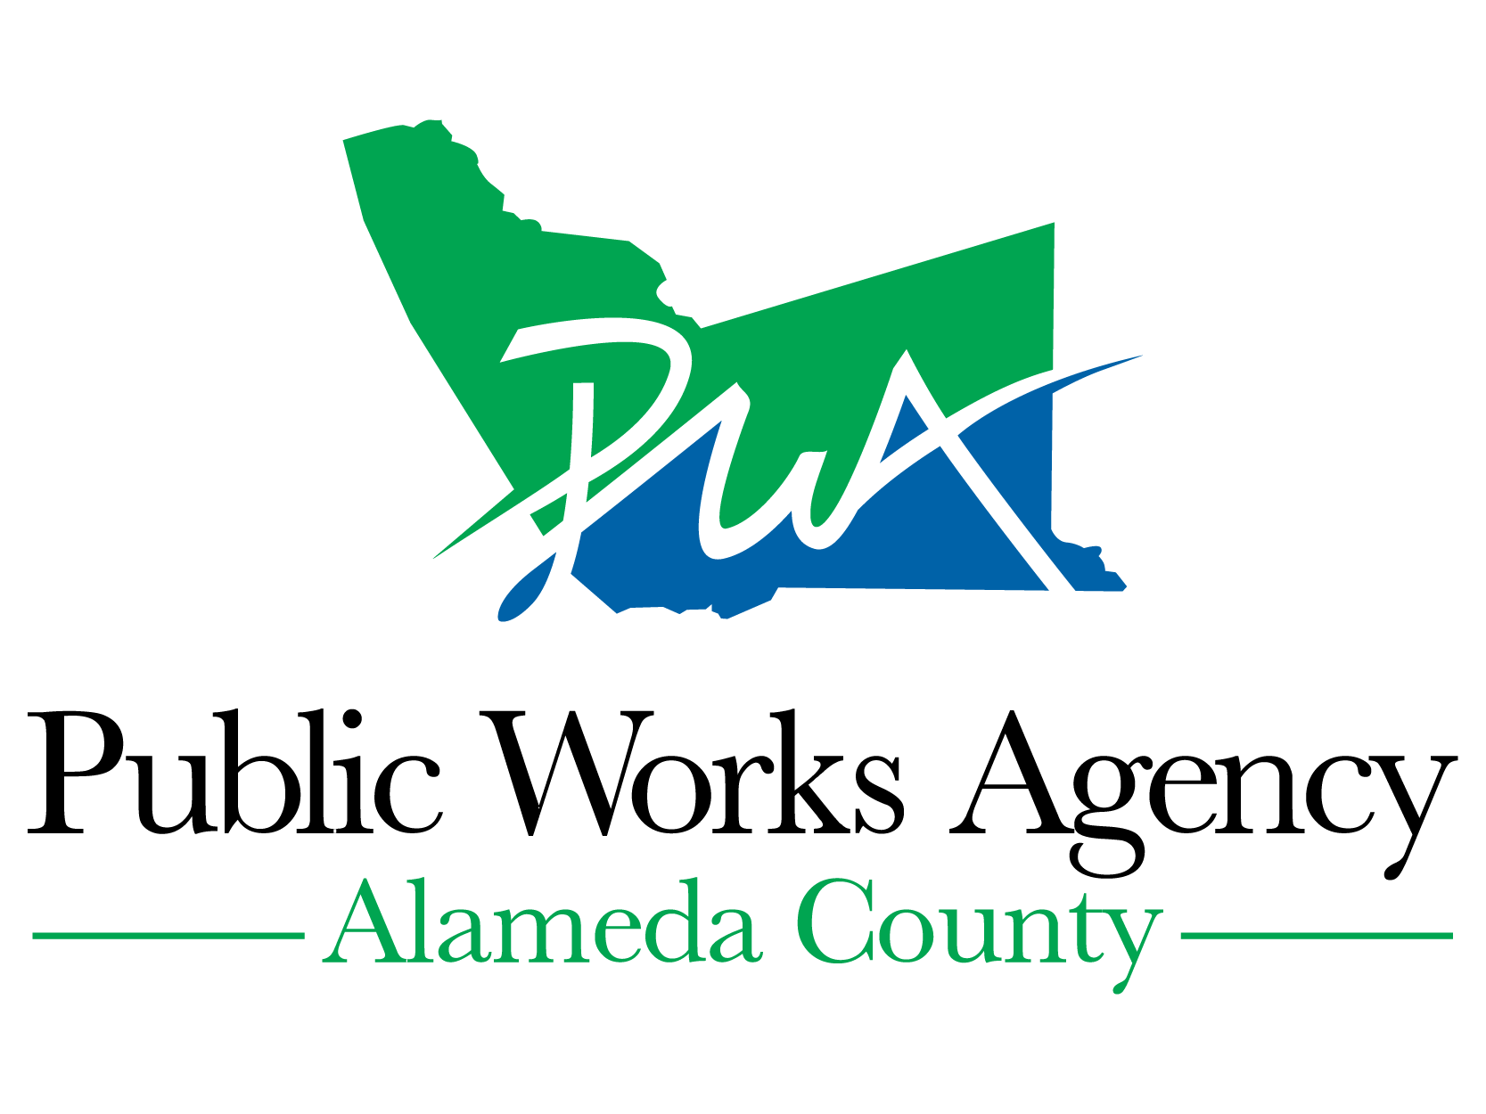

WELL COMPLETION REPORT RELEASE AGREEMENT—AGENCY
(Government and Regulatory Agencies and their Authorized Agents)

 | Project No./Site Address |  |  | City
Township, Range, and Section |  |  |  |  |  | Radius
(Must include entire study area and a map that shows the area of interest.)

Under California Water Code Section 13752, the agency named below requests permission from Department of Water Resources to inspect or copy, or for our authorized agent named below to inspect or copy, Well Completion Reports filed pursuant to Section 13751 to (check one):

Make a study, or,

Perform an environmental cleanup study associated with an unauthorized release of a contaminant within a distance of 2 miles.

In accordance with Section 13752, information obtained from these reports shall be kept confidential and shall not be disseminated, published, or made available for inspection by the public without written authorization from the owner(s) of the well(s). The information shall be used only for the purpose of conducting the study. Copies obtained shall be stamped CONFIDENTIAL and shall be kept in a restricted file accessible only to agency staff or the authorized agent.

Authorized Agent |  | Government or Regulatory Agency
Address |  | Address
City, State, and Zip Code |  | City, State, and Zip Code
Signature |  | Signature
Title |  | Title
Telephone ( ) |  | Telephone ( )
Fax ( ) |  | Fax ( )
Date |  | Date
E-mail |  | E-mail

